**Simulation Study of Regional Imbalance in Shared Bicycle Systems Based on System Dynamics**

1. **Research Problem**

With the acceleration of urbanization and the promotion of sustainable development, green travel has gradually gained popularity among citizens. Shared bicycles, as a key component of this trend, have quickly integrated into urban residents’ daily lives due to their low-carbon, convenient, and cost-effective advantages. They play an indispensable role in “last-mile” transportation.

However, this has introduced new management and resource allocation challenges for cities. Since users can return bicycles anywhere, the spatial distribution of bicycles is highly uneven. During peak travel periods, high-demand areas such as subway stations and commercial districts often experience shortages, while in low-demand areas, bicycles remain idle for long periods. This supply-demand imbalance not only diminishes user experience but also reduces resource utilization efficiency, becoming a critical factor limiting high-quality development of shared bicycle systems.

Against this backdrop, this study seeks to address the following research questions: In a typical urban shared bicycle system, how can simulation modeling capture the dynamic flow of bicycles across different functional regions and identify the key parameters and structural mechanisms that cause supply-demand imbalance? Is there a specific combination of parameters that can stabilize the system and achieve supply-demand balance?

To answer these questions, this study constructs a simplified but representative simulation model of a shared bicycle system based on system dynamics. Using a virtual city as the framework, the city is divided into three representative sub-regions: Region A (high-frequency areas such as subway stations and CBDs), Region B (medium-frequency areas such as residential and work districts), and Region C (low-frequency areas such as suburban or peripheral areas). Users may borrow bicycles in any region and return them in any region, with bicycles cycling between “available” and “in-use” states. The model incorporates multiple core variables and parameters, constructing a dynamic causal structure of “available bicycles → borrowing → riding → returning” to realistically reflect the spatial flow of bicycles.

The model accounts for user arrival rates, riding durations, and return preferences. Three experimental scenarios are designed by adjusting relevant parameters:

* **Scenario 1** simulates “high demand, low return” in hotspot areas to explore regional shortages;
* **Scenario 2** simulates “low demand, high return” in cold spots to analyze resource accumulation;
* **Scenario 3** models an ideal balanced state for comparison and system optimization.

Although the model is relatively simple, experiments show that different parameter combinations lead to distinct system behaviors. While simulation cannot fully capture real-world complexity, it provides a visual platform for exploring typical operational issues in shared bicycle systems.

The study has significance both theoretically and practically. Theoretically, the model emphasizes the supply-demand evolution from a system structure perspective. Unlike static data descriptions or traditional linear modeling, system dynamics focuses on causal loops, feedback mechanisms, and delays, revealing hidden structural factors in complex shared transport systems. Practically, the model provides empirical support for operators and city managers to optimize bicycle allocation and dispatch strategies. Sensitivity analysis of parameters allows evaluation of system responsiveness to user behaviors such as return preference and travel frequency, offering a low-cost experimental platform to improve service quality and resource efficiency.

**2. Model Construction**

To focus on internal supply-demand dynamics and ensure controllable simulation without external disturbances, the model adopts the following simplifications and assumptions:

1. **Region and User Behavior Assumptions:** The city is divided into three regions (A, B, C) representing high, medium, and low travel frequency areas. Users borrow bicycles in their current region and, after riding, return bicycles probabilistically to any region.
2. **Shared Bicycles as Reusable Resources:** Bicycles circulate continuously in the system, ignoring damage, loss, or maintenance. All bicycles cycle between “available” and “in-use” states, keeping the total number constant.
3. **Simplified Riding Behavior:** Riding duration is represented by a fixed average, ignoring path planning, traffic, or extreme behaviors. Bicycles automatically enter the return process after the average ride time.
4. **Probabilistic Returns:** Bicycle return regions follow set probability parameters, with probabilities summing to 1 across the three regions, reflecting the city’s return flow capacity.
5. **No Operational Dispatch Considered:** The model does not include any dispatch mechanisms; bicycle flow is entirely driven by user behavior.
6. **Closed System with No External Disturbance:** User numbers, bicycle totals, and regional structure remain constant. External factors such as weather, holidays, or traffic control are not considered; only normal weekday operations are simulated.

Under these assumptions, the model realistically reproduces basic system operation while isolating the supply-demand mechanism determined by user behavior and regional structure.

Three experimental scenarios were designed to explore typical operational problems: hotspot shortages, cold spot accumulation, and balanced borrowing-return dynamics.

* **Hotspot Shortage:** Region A represents a high-frequency area with significantly higher borrowing demand than other regions and lower return probability. Users’ arrival rate is higher, while return probability is lower, leading to supply shortage.
* **Cold Spot Accumulation:** Region C represents low-frequency areas with low borrowing rates but high return probability. Bicycles accumulate due to low outflow, while high-demand regions may experience shortages.
* **Balanced Borrowing and Returning:** Regions exhibit relatively matched demand and return probability, simulating an idealized equilibrium state for system comparison.

The model contains 18 parameters covering user behavior input, stock variables, flow variables, and global control. Key formulations include:

**1. Behavior Input Parameters (6):**

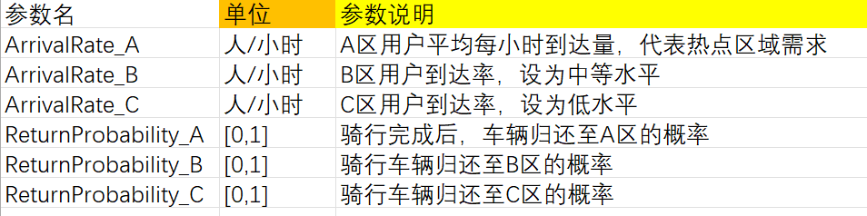

These parameters collectively determine the borrowing pressure in each region and the direction of bicycle return flows, serving as the direct driving forces of the system.

**2. Stock Variables (4)：**

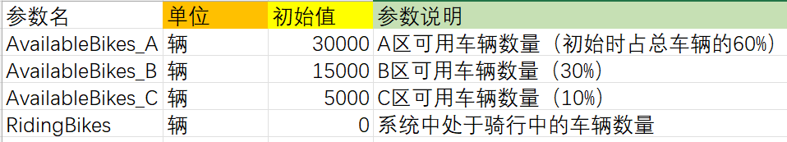

The initial number of bicycles in each of the three regions is set according to usage frequency, ensuring that each region has sufficient bicycles to meet user demand at the start of the simulation. The variable **RidingBikes** changes dynamically with user borrowing and returning behavior, reflecting bicycle utilization efficiency.

**3. Flow Variables (6):**

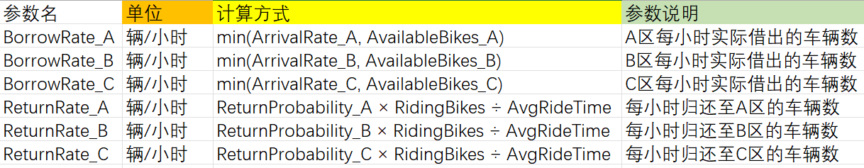

Bicycle borrowing flows are controlled using a minimum function to ensure that the number of bikes borrowed does not exceed the available stock. Returning flows are determined by the number of bicycles currently in use and the average ride time, capturing the real-world delay between borrowing and returning.

**4. Global Control Parameters (2)：**

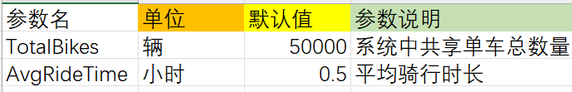

**TotalBikes** represents the sum of available and in-use bicycles. **AvgRideTime** affects the return rate and serves as the key parameter to implement time-delay effects in the model.

In Scenario 3 (Balanced Borrowing and Returning), these parameters are set to simulate a shared bicycle system in equilibrium. Other scenarios adjust key input variables based on this baseline to explore system behavior and imbalance under different conditions. Parameters not explicitly shown remain constant across all three experiments to ensure controlled and reliable comparisons. The specific parameter adjustments for the three scenarios are summarized in the table below.

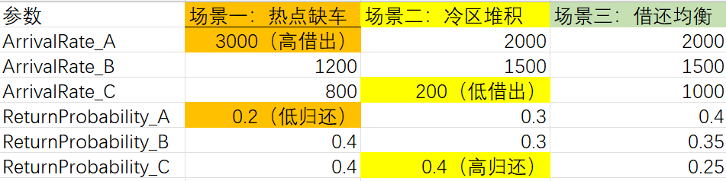

During the modeling process, the model follows a logical path of **abstracting the real-world problem → establishing variable relationships → constructing feedback structures → driving system evolution**, aiming to approximate real operational mechanisms as closely as possible while keeping the model simple and controllable.

First, the model treats the flow of shared bicycles as the core object, simplifying each bicycle’s lifecycle in the system into two states: **available** and **in-use**. Accordingly, the number of available bicycles in each region is modeled as an independent stock variable, named **AvailableBikes_A**, **AvailableBikes_B**, and **AvailableBikes_C**. A total stock variable, **RidingBikes**, represents all bicycles currently in use. These four stock variables allow the model to track in real time both the resource availability in each region and the overall system load.

Next, the model analyzes how user behavior affects the state of resources. When a user arrives in a region, if a bicycle is available, the user completes the borrowing action, and the bicycle transitions from the available to the in-use state. After completing the ride, the bicycle is returned to a region and re-enters the available state. In system dynamics, this process is modeled through **flow variables**. To capture regional differences, the model defines borrowing flows (**BorrowRate_A/B/C**) and returning flows (**ReturnRate_A/B/C**) for each region. All borrowing flows move from **AvailableBikes_X** to **RidingBikes**, and all returning flows move from **RidingBikes** to **AvailableBikes_X**, ensuring that the model captures the independent dynamics of each region.

Variable relationships are formulated based on real operational logic. Borrowing behavior is constrained by two factors: the **user arrival rate** and the **current stock of bicycles in the region**. If no bicycles are available, users cannot borrow, even if they are present. Therefore, the borrowing rate is expressed as:

BorrowRateX=min(ArrivalRateX,AvailableBikesX)

This reflects the mutual constraint between supply and demand. Returning behavior considers the **average ride time** and **user return preferences**. Bicycles currently in use are allocated to regions based on a set return probability (**ReturnProbability_X**), and the number of bicycles completing their ride per unit time is calculated as:

ReturnRateX=ReturnProbabilityX×RidingBikes/AvgRideTime​

Finally, to ensure the model runs successfully and allows for visualization, dependency paths between variables are manually established so that each flow variable correctly references the parameters or stocks it depends on. During simulation, **TimePlot** is used to display the changes over time in the number of available and in-use bicycles in each region, enabling observation of shortages or resource accumulation.

The three experimental scenarios are all built on a **common system structure**. By adjusting input parameters while keeping variables, formulas, and structure unchanged, the model reflects differences in user behavior and urban structure, allowing observation of bicycle flow trends across regions under different conditions.

**3. Simulation Results**

**3.1 Scenario 1: Hotspot Shortage**

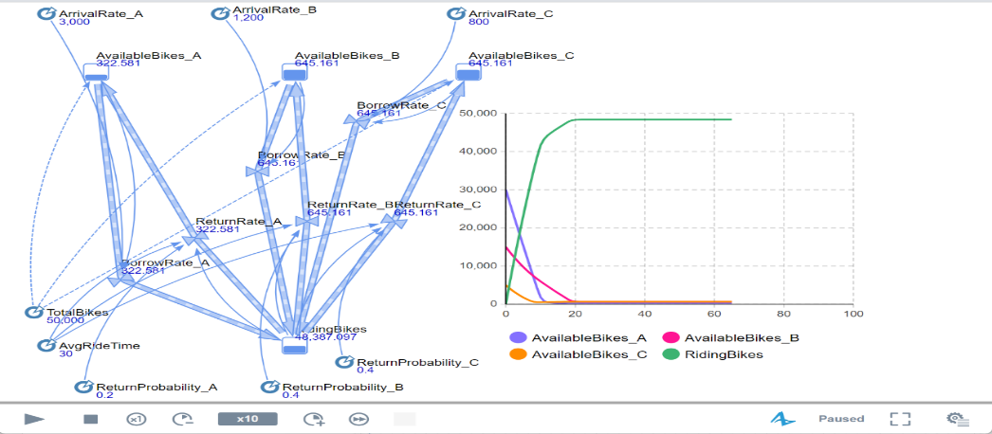

In this experiment, Region A is set as a typical hotspot, where the borrowing demand is significantly higher than in other regions (**ArrivalRate_A = 3000**) while the return probability is relatively low (**ReturnProbability_A = 0.2**), creating an imbalance of high borrow rates and low returns. As shown in the simulation curves, the system quickly falls into a state of resource scarcity and structural imbalance.

The number of available bicycles in Region A (purple curve) exhibits a steep decline in the early simulation period, dropping almost to zero within the first ten time units and remaining at very low levels thereafter. This indicates that a large number of bicycles are borrowed immediately, and due to the low return probability, the system cannot achieve effective bike inflow, turning Region A into a typical "bike shortage" area. Borrowing behavior in Region A becomes progressively constrained by the limited stock, leaving user demand unsatisfied. Meanwhile, available bicycles in Regions B and C (pink and orange curves) increase slightly in the early stage, suggesting that some bicycles leaving Region A are returned to these regions. However, this slight increase is quickly offset by continued borrowing. In the mid to late simulation, the available bicycles in Regions B and C also gradually decline to nearly zero. This demonstrates that, without external dispatch interventions, the system cannot achieve dynamic interregional resource rebalancing, and even non-hotspot regions struggle to maintain supply over time.

The total number of bicycles in use (green curve) rises sharply in the early stage and eventually stabilizes at a high level. This indicates that a large portion of bicycles is quickly borrowed and enters the riding state, but with the average ride time set at 30 minutes, bicycles return slowly, leaving the majority on the road and unavailable for new users. The combination of slow return and uneven inflow structure leads to persistent system inefficiency, showing that in real shared bike operations, relying solely on natural flows is insufficient to maintain stable supply in hotspot areas without active dispatch or return guidance mechanisms.

**3.2 Scenario 2: Coldspot Accumulation**

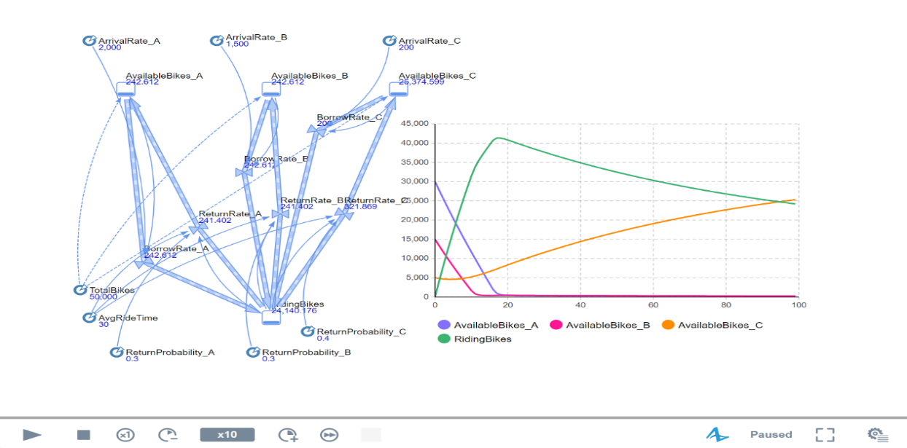

In this experiment, Region C is designated as a coldspot, with borrowing demand much lower than other regions (**ArrivalRate_C = 200**) but a higher return probability (**ReturnProbability_C = 0.4**), simulating areas where users often ride bikes to but rarely start trips from, such as suburban districts or industrial zones. As shown in the simulation, the system experiences a brief rapid transition before gradually showing typical resource accumulation.

Available bicycles in Region C rise slowly, eventually reaching a peak in the mid to late stages. This indicates that many bikes are returned to Region C after rides, but due to low borrowing rates, these bikes remain unused, forming a unidirectional accumulation. This accumulation results from the combination of model structure and parameter settings: high inflow attraction in Region C and low outflow due to limited borrowing. Meanwhile, available bicycles in Regions A and B drop sharply early on and approach zero later, indicating that even after brief inflows, bikes in these regions are quickly borrowed, leaving them in persistent shortage.

The total number of bicycles in use initially spikes and then gradually decreases. This shows that while many bikes are borrowed and in use early, they mainly originate from Regions A and B but are returned to Region C, creating accumulation and reducing the system’s active circulation. As the effective cycle slows, the number of bikes in use declines, severely limiting system efficiency. This experiment demonstrates that without dispatch mechanisms or user guidance, such accumulation cannot self-correct, resulting in idleness in some regions and extreme shortages in others.

**3.3 Scenario 3: Balanced Borrowing and Returning**

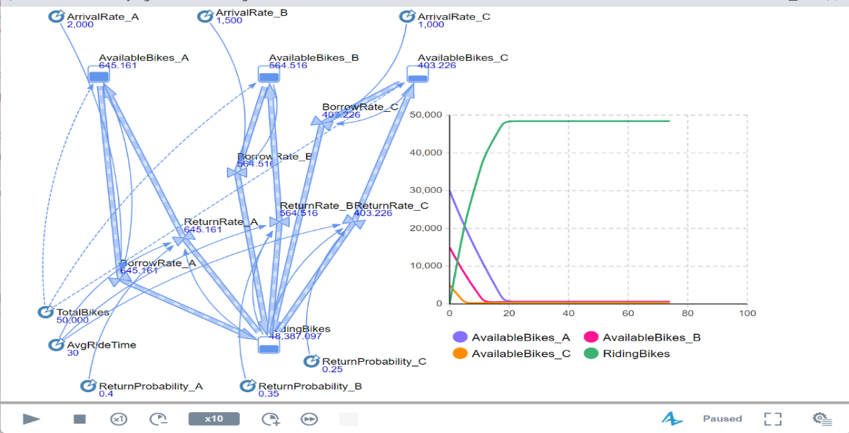

In this experiment, borrowing demand and return probabilities across the three regions are set to approximate a supply-demand balance and relatively reasonable structure.

Simulation results show that borrowing rates across the three regions are similar, and available bikes rapidly decrease during the early simulation, approaching zero within 10–20 time units. This indicates that available bicycles are quickly borrowed, depleting stock. The total number of bikes in use rises rapidly, peaking around 20 time units and then stabilizing, showing that a significant portion of bicycles has entered the riding state.

Despite reasonably set **ReturnProbability_X** and **ArrivalRate_X**, the system experiences an initial borrowing peak, and the delay imposed by average ride time causes inventory depletion, leading to low-efficiency operation. This demonstrates that even with balanced parameters, without external intervention or dynamic adjustment, the system may still fall into dysfunction.

Comparing the three scenarios shows that system stability depends not only on balanced parameter settings but also on the feedback structure and the control of time delays. Insufficient returns in hotspots cause continuous resource outflow; excessive returns in coldspots cause accumulation. Even seemingly balanced systems can suffer inefficiency due to initial demand surges and delayed returns. This indicates that relying solely on natural user behavior cannot achieve high-efficiency operation; active interventions—such as dispatch mechanisms, user guidance strategies, or intelligent control—are necessary to break the imbalance and achieve truly dynamic stability and efficient resource circulation.

**4. Research Summary**

This study uses **system dynamics** as the main methodology and builds a multi-region shared bike simulation model on the **AnyLogic** platform. By setting different experimental scenarios, it simulates three typical system states: hotspot shortages, coldspot accumulation, and balanced borrowing/returning.

Although the overall experimental logic and model are relatively simple, the modeling and experimentation process reveals several limitations.

**First**, for clarity and operational simplicity, the model simplifies the real shared bike system. For example, it only considers three urban regions and ignores real-world factors such as physical distances, geographic constraints, traffic congestion, and weather. This allows rapid abstraction and demonstration of dynamic mechanisms but limits precision in capturing real-world complexity and spatial heterogeneity.

**Second**, variable settings are idealized. User arrival rates and return probabilities are treated as continuous and constant, ignoring peak/off-peak fluctuations, random behavior, or holiday effects. Variables such as “ride distance” and “individualized ride time” are not considered, meaning the model primarily simulates macro trends and cannot fully capture feedback effects of individual behaviors.

**Third**, although the model runs successfully, there is room for improvement. For example, no bike dispatch mechanism is included. In reality, operators deploy vehicles and personnel to redistribute bikes from surplus to deficit areas. In this study, bike flow depends entirely on natural user borrowing and returning, with interregional transfers determined solely by return probabilities, lacking active dispatch simulation.

**Future directions for model enhancement** include:

1. Introducing **geographic or network-based modeling** to simulate bike flow and distribution at specific locations.
2. Incorporating **diverse user behaviors**, such as peak-hour surges or multimodal travel choices, to better reflect realistic usage.
3. Adding **operating agents or dispatch mechanisms** so bikes can circulate proactively, reflecting the regulatory role of operators.
4. Using **real operational data** (e.g., regional borrowing/return distributions, user trajectories, ride durations) for parameter calibration, data fitting, and sensitivity analysis, enhancing model realism and predictive accuracy to support management decision-making.